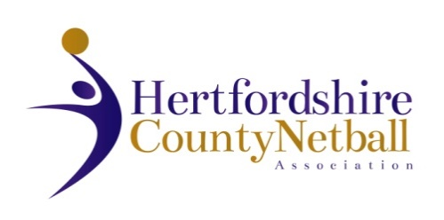

**HERTFORDSHIRE COUNTY NETBALL ASSOCIATION**

ANNUAL GENERAL MEETING

**WEDNESDAY 7th JUNE 2023 7.30pm**

**AGENDA**

1. Chair’s Remarks
2. Apologies for Absence
3. Minutes & Matters Arising from last AGM 8th June 2022
4. Awards 1 & 2 (Joy Hooper Trophy - Contribution to a netball league & Rose Harris Award – most qualified umpires in a league)
5. Treasurer’s Report
6. Adoption of Statement of Accounts 2022 - 2023
7. Agree County Affiliation Fees 2023 - 2024
8. Appointment of Auditor
9. Awards 3 & 4 (NexGen Outstanding Club Award & Maureen Ball Young volunteer Award)

1. Annual Reports from TSG leads and NDO only (League reports contained in AGM booklet)
2. Election of Officers:

No officers to be elected/re-elected this year

1. Proposed amendments to HCNA Constitution
2. Awards 5 & 6 (Daphne Payne Officials Award & Dorothy Broad Administrators Award)
3. Awards 7 & 8 (Jenny Evans Coaching Award & Netball Teacher award) + any special awards
4. Date of next Annual General Meeting: Wednesday, 12 June 2024

END OF AGM

**Any Other Business** – an opportunity for members to raise any queries/requests/desires with the County Committee.