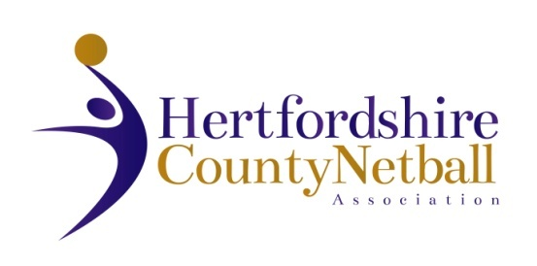

Please note that the Hertfordshire County Netball Association 2023 AGM will be held on Wednesday 7 June 2023.

The HCNA AGM details are as below:

* Date: Wednesday 7 June 2023
* Time: 7.30 pm
* Venue: International Suite, Herts Sports Village, De Havilland Campus, Hatfield AL10 9EU

A proposed Agenda is attached.

Also attached is a Proxy form if you wish to nominate an affiliated member who is attending to represent you with a proxy vote.

We look forward to welcoming as many of you as possible to the meeting.

There are resolutions proposed by the Hertfordshire County Committee this year. One is an amendment to the Constitution, the other an action for this year only. Please see attached proposals which will be voted on at the AGM.

If you have a resolution for the AGM, this needs to be submitted in writing by two Hertfordshire County Netball Association affiliated members with AGM voting rights (see below).  **Please submit any resolutions to Cathy Williams, Chair of HCNA by email by 31 May 2023, midnight at the latest.**The email address is cathy.w@btinternet.com. No resolutions can be tabled at the meeting.

One representative from each affiliated netball club or educational institution, independently affiliated members and HCNA elected members shall be entitled to one vote each (excluding nominated proxy votes).