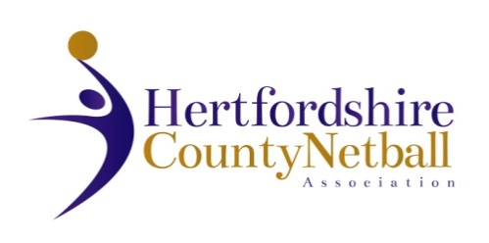

HERTFORDSHIRE COUNTY NETBALL ASSOCIATION
ANNUAL GENERAL MEETING
WEDNESDAY 10th JUNE 2026 7.30pm

AGENDA

- Chair’s Remarks

- Apologies for Absence

- Minutes & Matters Arising from last AGM 11th June 2025

- Introduction to HCNA awards and prizes and nominations for 2026

- Awards 1 & 2 (Joy Hooper Trophy - Contribution to a netball league & Rose Harris Award – most qualified umpires in a league)

- Treasurer’s Report

- Adoption of Statement of Accounts 2025 – 2026
- Agree County Affiliation Fees 2026 – 2027
- Appointment of Auditor

- Awards 3 & 4 (NexGen Outstanding Club Award & Maureen Ball Young Volunteer Award)

- Annual Reports from TSG leads and NDO only (League reports contained in AGM booklet)

- Election of Officers:

Roles with volunteer willing to stand for re-election
Chair – Officials Technical Group
Chair – Performance Technical Group
Other Roles – current volunteer to stand down
Chair
Treasurer

- Awards 5 & 6 (Daphne Payne Officials Award & Dorothy Broad Administrators Award)

- Awards 7 & 8 (Jenny Evans Coaching Award & Netball Teacher award) + any special awards

- Proposed date of next Annual General Meeting: Wednesday, 16 June 2027

- Message from our President, June Griffith

END OF AGM

Any Other Business – an opportunity for members to raise any queries/requests/desires with the County Committee.

