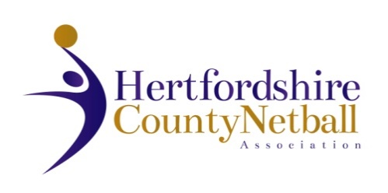

**HERTFORDSHIRE COUNTY NETBALL ASSOCIATION**

ANNUAL GENERAL MEETING

**WEDNESDAY 9th JUNE 2021**

**7.00pm via Zoom**

**AGENDA**

1. Chair’s Remarks
2. Apologies for Absence
3. Minutes & Matters Arising from last AGM 22nd July 2020
4. Awards 1 & 2
5. Treasurer’s Report
6. Adoption of Statement of Accounts 2020 - 2021
7. Agree County Affiliation Fees 2021 - 2022
8. Appointment of Auditor
9. Awards 3 & 4
10. Annual Reports from TSG leads and NDO only (League reports contained in AGM booklet)
11. Election of Officers:

County Secretary

**Roles with volunteer willing to stand for re-election**

Chair of HCNA

Chair of Coaching TSG

1. Awards 5 & 6
2. Date of next Annual General Meeting: Wednesday, 9 June 2022
3. Awards 7 & 8 + any special awards