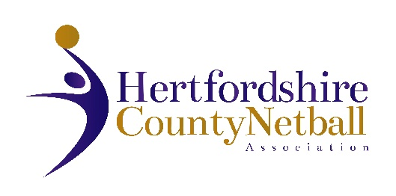

Please note that the Hertfordshire County Netball Association 2025 AGM will be held on Wednesday 10 June 2026.

The HCNA AGM details are as below:
- Date: Wednesday 10 June 2026
- Time: 7.30 pm
- Venue: International Suite, Herts Sports Village, De Havilland Campus, Hatfield AL10 9EU

A proposed Agenda is below.

Also attached is a Proxy form if you wish to nominate an affiliated member who is attending to represent you with a proxy vote.

We look forward to welcoming as many of you as possible to the meeting.

There are no resolutions proposed by the Hertfordshire County Committee this year.
If you have a resolution for the AGM, this needs to be submitted in writing by two Hertfordshire County Netball Association affiliated members with AGM voting rights (see below). Please submit any resolutions to Cathy Williams, Chair of HCNA by email by 31 May 2026, midnight at the latest. The email address is cathy.w@btinternet.com. No resolutions can be tabled at the meeting.
Also attached is a nomination form for the roles of Chair, County Treasurer, Performance TSG Lead and Officiating TSG Lead which are liable for election or re-election. Role specifications are attached. Any nominated individual should submit a written statement (no more than 300 words) with the nomination form by 31 May 2026, also to Cathy Williams via email.

One representative from each affiliated netball club or educational institution, independently affiliated members and HCNA elected members shall be entitled to one vote each (excluding nominated proxy votes).

