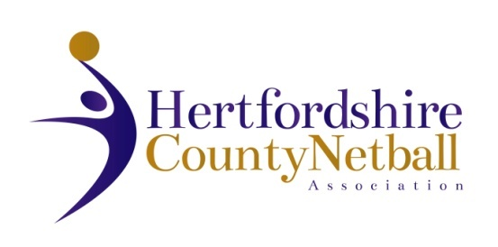

Please note that the Hertfordshire County Netball Association 2021 AGM will be held on Wednesday 9 June 2021. This will again be a ‘virtual AGM’ to ensure the event is delivered in a safe environment and within the Government’s guidelines.

The HCNA AGM details are as below:

•        Date: Wednesday 9 June 2021

•        Time: 7.00 pm

•        Zoom Login details, final Agenda and other documents will follow in a separate email to those who respond to this email. A proposed Agenda is attached.

We look forward to welcoming as many of you as possible to the meeting.

**Please reply to FLORRIE JONES, HERTS NDO to advise if you wish to attend the AGM as soon as possible and by 1 June 2021 LATEST**

[**florence.jones@englandnetball.co.uk**](mailto:florence.jones@englandnetball.co.uk)

**Only those who respond positively will be sent joining instructions.**

There are no resolutions being proposed by the Hertfordshire County Committee this year.  If you have a resolution for the AGM, this needs to be submitted in writing by two Hertfordshire County Netball Association affiliated members with AGM voting rights (see below).  **Please submit any resolutions to Cathy Williams, Chair of HCNA by email by 26 May 2021, midnight at the latest.**The email address is cathy.w@btinternet.com. No resolutions can be tabled at the meeting.

Also attached is a nomination form for one vacancy on the County Committee – County Secretary plus the roles of Chair of Coaching Technical Group and County Chair, which are liable for re-election. Role specifications are attached. Any nominated individual should submit a written statement (no more than 300 words) with the nomination form by 26 May 2021, also to Cathy Williams via email.

One representative from each affiliated netball club or educational institution, independently affiliated members and HCNA elected members shall be entitled to one vote each (excluding nominated proxy votes).