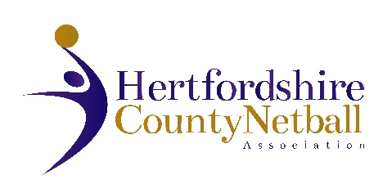

NOTICE TO ALL VOTING MEMBERS

HERTFORDSHIRE COUNTY NETBALL ASSOCIATION
ANNUAL GENERAL MEETING
PROXY FORM

The AGM will be held on Wednesday 10th June 2026 at 7.30p.m.at the Herts Sports Village, Hatfield.

The AGM is a mandatory legal requirement and adopts the Statement of Accounts and elects your County Committee.

You are encouraged to attend, or alternatively nominate an affiliated member to represent you with a proxy vote.

Confirmation of Proxy Vote

Name of Affiliated Club, Educational Institution or Independent Registered Participant not attending the AGM

-------------------------------------------------------------------------------------------------------

Name of Affiliated Club, Educational Institution or Independent Registered Participant holding your Proxy Vote for voting on your behalf at the AGM

-------------------------------------------------------------------------------------------------------

Please return to Cathy Williams, Chair of HCNA, by email cathy.w@btinternet.com by 31 May 2026 at the latest

