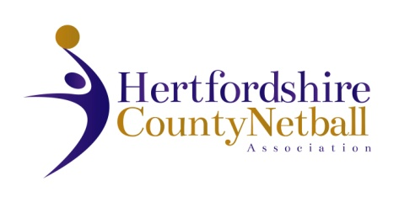

**OFFICIALS TECHNICAL SUPPORT GROUP (“OTG”)**

**ROLE REMITS (Final Version: January 2015)**

**CHAIR**

* Chair OTG meeting
* Approve draft minutes and set agenda, send to Database/Archives Co-ordinator
* Ensure all League Representatives are informed of regional/ national officiating policies
* Appoint EN Tutors to Hertfordshire C Award Courses
* Act as primary contact for all officiating matters across Hertfordshire – directing to other channels as appropriate
* YUA liaison with schools and clubs including liaison with the County Competition and Young People TSG
* First contact for England Netball and East Region Netball matters