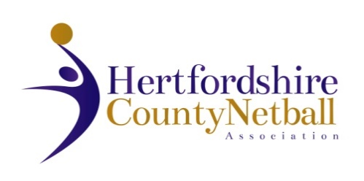

**HERTFORDSHIRE COUNTY NETBALL ASSOCIATION**

ANNUAL GENERAL MEETING

HERTS SPORTS VILLAGE, INTERNATIONAL SUITE,

HATFIELD AL10 9EU

**WEDNESDAY 8th JUNE 2022**

**7.30pm**

**AGENDA**

1. Chair’s Remarks
2. Apologies for Absence
3. Minutes & Matters Arising from last AGM 9th June 2021
4. Awards 1 & 2
5. Treasurer’s Report
6. Adoption of Statement of Accounts 2021 - 2022
7. Agree County Affiliation Fees 2022 - 2023
8. Appointment of Auditor
9. Awards 3 & 4
10. Annual Reports from TSG leads and NDO only (League reports contained in AGM booklet)
11. Election of Officers:

County Secretary

**Roles with volunteer willing to stand for re-election**

Chair of Young People & Competition TSG

Chair of Performance TSG

Chair of Officiating TSG

County Treasurer

County Vice-Chair

1. Awards 5 & 6
2. Awards 7 & 8 + any special awards
3. Date of next Annual General Meeting: Wednesday, 7 June 2023