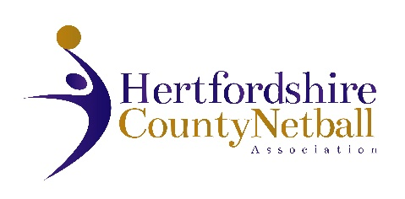

# NOTICE TO ALL VOTING MEMBERS

## HERTFORDSHIRE COUNTY NETBALL ASSOCIATION

ANNUAL GENERAL MEETING

PROXY FORM

The AGM will be held on Wednesday 8th June 2022 at 7.30p.m.at the Herts Sports Village, Hatfield.

The AGM is a mandatory legal requirement and adopts the Statement of Accounts and elects your County Committee.

You are encouraged to attend, or alternatively nominate an affiliated member to represent you with a proxy vote.

### Confirmation of Proxy Vote

**Name of Affiliated Club, Young Persons Group, Educational Institution or Independent Registered Participant not attending the AGM**

**-------------------------------------------------------------------------------------------------------**

**Name of Affiliated Club, Young Persons Group, Educational Institution or Independent Registered Participant holding your Proxy Vote for voting on your behalf at the AGM**

**-------------------------------------------------------------------------------------------------------**

Please return to Cathy Williams, Chair of HCNA, by email [cathy.w@btinternet.com](mailto:cathy.w@btinternet.com) **by 30 May 2022 at the latest**