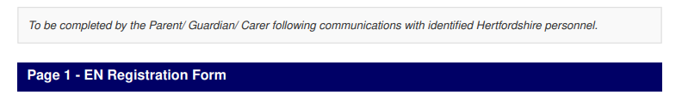

Parent / Guardian Email: |  | Parent / Guardian Address:
Name of Umpire: |  | Umpire’s DOB:
ENA ID: |  | Club/School (add both if applicable):
County: |  | Region:
Hertfordshire |  | East
Current Umpire Qualification (Please put Y where applicable)
In Training: | INTO: | C Award: | B Award:

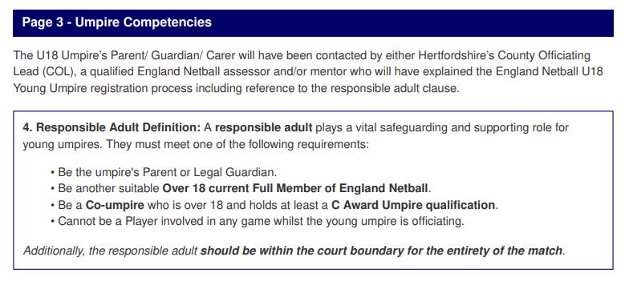

- What level of competition is the Umpire currently umpiring?
- How regularly is the Umpire currently umpiring?
- Who will be the Responsible Adult (refer to Adult definition clause on previous page) whilst the young umpire is umpiring the new level of competition?
- What is the position of the Responsible Adult whilst the young umpire is umpiring the new level of competition? *Delete below where appropriate
Parent / Guardian /Carer Yes / No
Other Yes / No If yes, please specify:
- What monitoring strategy has been agreed between the COL/Umpire/Mentor?
The umpire will be monitored either by the League Officiating Lead and / or Mentor or COL
- (INSERT NAME HERE) has demonstrated the physical ability to umpire at a higher level *
Yes / No
- (INSERT NAME HERE) has demonstrated the emotional ability to transition to umpire at a higher level
Yes / No
- (INSERT NAME HERE) has the skills and knowledge to umpire at a higher level
Yes / No
- (INSERT NAME HERE) will work with a mentor to regularly review progress *
Yes / No

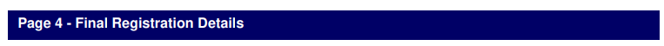

Parent/ Guardian Name:
Parent/ Guardian Email:
Date:

Please return this form to Florrie Jones: hertfordshirenetball@gmail.com

